Emergency Response Postures
VAMC Martinsburg, WV

Although the variety of emergencies that could occur at the Medical Center are infinite, there are only five basic response postures the Medical Center will execute to help preserve the safety and well being of patients, staff, visitors, and contractors.
Lock in
Lock down
Shelter in place
Evacuation
Deep Shelter (Duck, cover, and hold)

Contractors are responsible to ensure all employees and subcontractors under their purview are familiar with these procedures. Execution of an emergency response posture is mandatory when directed.

Primary Communication: Public Address (Indoor and Outdoor)
Secondary Communication: Emergency Horn (3 long bursts)

I. “Lock In”

This is a posture taken in response to an event that occurs outside of buildings on campus or off campus. The key components of a “lock in” are:
1. Lock all exterior doors.
2. Pull all shades/blinds where available and remain clear of windows where possible.
3. No one is allowed to leave or enter the building.
4. Police Service will activate Code White and restrict access to the campus.
5. Normal routines inside your building may continue.

Below are examples of when we may “lock in”:
A violent incident at the new Mental Health Building where the perpetrator was on the loose: All other buildings would lock in, preventing the perpetrator from entering their spaces.
The Credit Union is robbed and the perpetrator is on the loose. All buildings would lock in and the Police Service would activate a Code White to secure the campus.

The Incident Commander will secure from a lock in after the Police Service has determined, to the best of their ability that a threat no longer exists.

It is important to note that you will not be permitted to enter or leave the building for any reason during a lock in. Please make sure that you have a contingency plan for any family responsibilities you may have.

Lock in will be ended via standard emergency communication means.

II. “Lock down”

Lockdown is a response posture taken when there is a violent incident in your building or in the immediate vicinity around your building. The key components of a “lock down” include:
1. If you are in an open space, gather all patients and visitors in your vicinity and get behind the nearest door you can lock.
2. If you are in an office space, quickly lock your door.
3. Once safely behind a locked door, kneel or sit on the floor and position yourself behind furniture and out of the line of sight from the door or window.
4. Police will activate Code White and respond aggressively with overwhelming force.

Key points to remember during “lock down”:
1. It is not uncommon for a person committing violent acts to use all means possible to expose more potential victims. If the fire alarm sounds while you are in lock down, you must personally make the decision to evacuate or remain in lockdown. The prevailing thoughts are that minus smoke, heat, or flames you are safer remaining locked down.
2. Public Address announcements are suspect when violent intruder(s) are in the building. A PA announcement may be coerced or made by the perpetrator. Do not follow PA instructions during lock down.
3. Attempts to get you to unlock your door, either verbally or through knocks are to be considered suspect. You may recognize the voice asking “Open up, let me in”, but you do not know if that person is acting in response to coercion.
4. Do not, under any case, rush a police officer during their response to a violent incident. The officer is required to consider every person a potential suspect while responding to a violent act. You are a suspect until cleared by police. If you see a police officer approaching get against a wall, stay still, and raise your hands so they are in plain view. In no case should you put your hand in your pocket or make any other action which could give the appearance of reaching for a weapon. Once cleared, the officer will direct you where to go and what to do.

Lock down will be ended by a police officer, firefighter, or other agency official unlocking your door.

III. Shelter in Place

An order to Shelter in Place by the Incident Commander will be issued when there is an environmental condition outside of your building that is potentially harmful. The overall purpose of sheltering in place is to keep the “bad” air out and the good air in. The following actions shall be taken when directed to Shelter in Place:
1. FMS will stop the exchange of air flow in Bldg 500 HVAC’s to minimize the drawing in of outside air.
2. All staff with window Air Conditioning units shall turn them off immediately.
3. All staff is to close all doors and windows in your space.
4. No one is allowed to enter or leave the building.
5. Persons outside when Shelter in Place is ordered should report to the chapel, Bldg 117 for isolation Shelter in Place.
6. The Police Service shall restrict access to the campus during Shelter in Place.
7. Communication during shelter in place will be via normal emergency channels.

All staff is cautioned not to allow any person who is outside at the time Shelter in Place is set into any building other than the chapel. There is a potential that people who were outside may have been contaminated by the source that resulted in the call to Shelter in Place.

IV. Evacuation

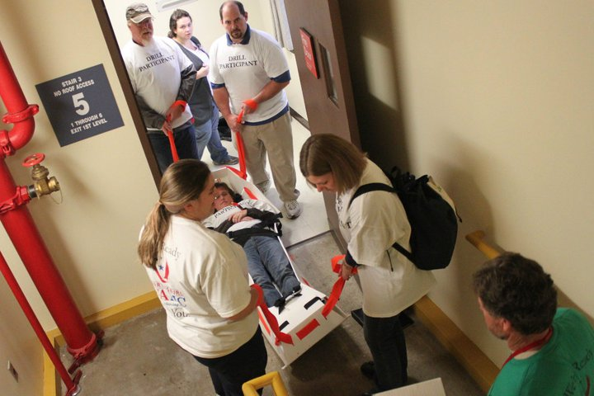

The Medical Center has two primary evacuation plans; horizontal and vertical. Horizontal evacuations are the initial response to an order to evacuate and are covered through the fire plan. This emergency response deals with vertical evacuations only. All contractors are required to be familiar with this and horizontal evacuation procedures.

A full vertical evacuation may only be authorized by the Incident Commander. Please keep in mind the Incident Commander is staffed only in emergencies; it is not a job title or position. In a fire or unsafe building scenario, the Incident Commander may very well be the Fire Department or Police Supervisor.

The goal of an order to evacuate is to remove all patients, visitors, staff, and contractors as swiftly as possible from harm’s way. However, our responsibility to our patients requires us to modify the normal evacuation protocol. Unless you are in imminent danger, or the below process would put you in immediate danger, the following actions shall be taken by staff not delegated specific duties during a vertical evacuation:
6B: Even numbered rooms report to 5A, odd number rooms report to 5C to expedite the evacuation of inpatients.*

5B: Report to 4C to expedite the evacuation of inpatients.*

4B: Report to 4A to expedite the evacuation of inpatients.*

3A: Report to 3B to expedite the evacuation of inpatients.*

3C: Report to Bldg 501 (Long Term Care) to expedite the evacuation of inpatients.

2nd floor: Report to Bldg 501 (Long Term Care) to expedite the evacuation of inpatients.

1st floor: Assist all patients and visitors in evacuating the building.

*Evacuchairs and evacusleds are located in strategic places throughout the Medical Center to assist in the evacuation of people who are unable to make it down the stairs themselves.

V. Deep Shelter/Duck, Cover, and Hold
This response will be utilized whenever tornado warnings are in effect and/or a tornado has been spotted within 20 miles of the Medical Center campus or an individual CBOC. The purpose of this response is to provide patients, staff, visitors, and contractors the highest protection available in the event of a tornado. The key components of Deep Shelter include:
- The safest place to be in the event of a tornado is the basement.
- If you are unable to make it to the basement, you should seek shelter on the lowest floor possible.
- Regardless of what floor you are on, seek shelter in an interior space without windows. Close all doors leading to rooms with windows.
- Patient wards should move all patients from the rooms to an interior hall.
- Wherever you are, if you hear a tornado (Sounds similar to a loud, unrelenting locomotive), Duck, cover, and hold:
- Duck under a desk or other furniture.
- Cover all vital organs and tuck your chin to your chest.
- Hold onto a solid piece of furniture or other sturdy anchor..

If a tornado strikes your building, be very cautious when you exit. Always remember the structure of the building may have been damaged and there will be dangerous debris everywhere.

