Design-Build (DB) Scope of Work
Replace Flagpole Bldg 1 DB
595-25-109
Construction Documents Ready by 90 days after Notice to Proceed (NTP) issued
Construction Complete by 220 days after NTP issued
Contracting Officer: TBD
Contracting Officers Representative (COR): Nicholas K. Bierman

-- Services --

- Provide all labor, materials, tools and equipment, and the design-build services necessary for design and construction of a project described herein as well as other specific tasks as further defined by this Request for Proposal (RFP) the Design-Build Project No. 595-25-109, Replace Flagpole Bldg 1 D/B. The resultant contract of this procurement is to provide required design completion of the aforementioned project and perform construction of completed design work. Project shall be designed and completed in accordance with VA Criteria, EPA requirements, and VA Specifications developed for the project.
- This Request for Proposal (RFP) document is intended to generally define the scope and design parameters to be included in this project. It is the responsibility of the Design-Build team to provide a complete set of approved design documents in a manner consistent with the VA guidelines, specifications, and design standards in order to complete construction within a 220-day schedule.
- Offeror shall be prepared for a 220-day schedule as indicated below in the Project Schedule. Offeror may propose an alternate schedule, in addition to the 220-day schedule, which will be reviewed by the VA. Schedules shall indicate the following:
- The design period which shall include provisions for VA reviews.
- Phasing plans for coordination of any site utility relocation work.
- Construction period services including:
- Mobilization
- Demolition
- Procurement and installation of equipment
- Provisions for overtime or shift work shall be included in the contract offer.
- Equipment unloading, placing, inspection, testing, commissioning, and reports.

PROVIDE:
Professional Design-Build (DB) and healthcare planning services to include but not limited to:
- Site investigation – architectural, civil, structural, electrical, mechanical and any other engineering services as needed, environmental studies, and materials testing.

- Contract drawings and specifications for construction.
- Construction period services for DB A/E - review of shop drawing submissions, provide recommendations regarding contractor change proposals and requests for information (RFI), DB A/E shall visit site per VA's request, add to drawings as-built conditions from contractor's record drawings; DB A/E shall respond on site within a two-hour period when requested.
- Construction and Installation services of the ATS’s, including all Management, Supervision, Labor, Transportation, Equipment and Materials and to perform work to include demolition, general construction, alterations, mechanical and electrical work, and certain other items as required by project drawings and specifications to create a complete and useable facility.
-- Project Scope --
GENERAL:
Provide sufficient construction documents for a project that shall Replace the Flagpole and provide some minor modifications to Landscaping adjacent to Building 1 the Lebanon VA Medical Center. Offeror shall be prepared to make layout changes, calculations, and provide documentation to support their design. Restoration of site and landscaping to take place will be designed and installed as per the specifications and drawings approved through the Design and Project Design Team (PDT) process.
SPECIFICS:
The project is intended to replace the flagpole in front of Building 1 and to improve the general aesthetics of the overall area and improve access to provide the veterans a space to congregate:

- Replace the 90-foot flagpole and reduce the grade of the surrounding area to meet current VA requirements for access.
- Add additional seating and observation areas for flagpole and ceremonies.
- Relocate the six service flags to create a more unified appearance.
Construction shall be addressed in phases to allow operations to continue during construction to the greatest extent possible. Phasing shall be determined during the 35% design review. Phasing must work within budget and allow the VA to continue operations at minimal interference.
The DB A/E is responsible for providing certified industrial hygiene services to perform asbestos survey investigations, bulk sampling, development of specifications and drawings, and construction period services. All designs shall be accomplished in accordance with VA guidelines and specifications, which are available on the Internet at http://www.cfm.va.gov/til/. DB A/E shall pay particular attention to NFPA, BOCA, VA Handbook 7610 space criteria and VA program guide PG-18-14. SPECIAL NOTE: Be reminded that the VA guidelines are just a guide, and the project is not bound by them. If current healthcare trends dictate a different design approach is needed, we shall follow that approach.
The DB A/E shall provide professional architectural and engineering and construction services for the project and is responsible for providing all services necessary for design of this project – i.e. mechanical, electrical, asbestos sampling and monitoring, structural, fire alarm and suppression, communications, cable tv, etc.
The DB construction contractor shall provide all Management, Supervision, Labor, Transportation, Equipment and Materials and perform work to include demolition, general construction, alterations, mechanical and electrical work, and certain other items as required by project drawings and specifications complete the Cooling Tower Replacement Project.

-- Site Investigations --

EXPECTATION: The DB A/E shall make site visits as necessary to survey existing conditions.
Make site visits as required to determine existing as-built conditions affecting this project. NOTE: Information including drawings and other documentation provided to the DB A/E is used as reference only. All additional references and specifications are available in VHA’s Technical Information Library at address: http://www.cfm.va.gov/til/. AutoCAD background drawings will be provided by the VA upon request. The DB A/E shall field verify all dimensions. The DB A/E shall field verify every aspect that relates to the project. Coordinate site visits with the Contracting Officer Representative (COR) as determined after award.

-- Project Schedule --

EXPECTATION: Submit review packages so they are received on the noted day

SUBMISSIONS:
Submit review packages so they are received on the noted day (calendar days after NTP) or earlier:
Initial PDT Meeting 0 days
Design Development Documents (35%) 40 days
(PDT Meeting) 45 days
Design Development Documents (100%) 65 days
(PDT Meeting) 70 days
Construction Documents 90 days
Begin Construction on or before 100 days
Complete Construction on or before 220 days
Note: The issuance of the Notice to Proceed (NTP) for design will be at the first Project Design Team (PDT) Meeting. The Design-Build Team Contractor shall be required to attend and take minutes of each PDT meeting. Minutes shall be submitted electronically to the Project Manager and Contracting Officer within three calendar days of each meeting for approval and to be added to the official contract file.

-- Design Requirements/Submissions --

EXPECTATIONS: Submit complete review package in accordance with the following requirements and guidelines outlined in http://www.cfm.va.gov/til/aeDesSubReq.asp Please pay specific attention to the schematic, design and construction submission requirements. As appropriate and depending upon the complexity of the design, the DB A/E may elect to delete individual submissions where not required (i.e. Do not address Site Development, Landscaping for interior renovation projects)
DELIVER:
Submit all design/bid submission packages directly to the Contracting Officer Representative on the established dates to allow the VA time to review. Include all information as follows and as outlined in the attachments for each submission. Information required for each submittal is outlined in Program Guide PG-18-15 Volume C November 2008. The manual is available at the following address: http://www.cfm.va.gov/til/aeDesSubReq.asp
Area of Construction: See Attachment “A”.
Design Development 35%: Attachment “B” 35% Submission Requirements
- Requirements for the 35% Design Development Documents Submission.
- Define the design elements based on the presented option and submit all information required by the PG-18-15 (35% Design Development).
- Identify Working Drawings scope within the construction budget.
- Identify all design calculations.
- Identify impact of existing asbestos.
- Develop plans and marked up specifications to meet all applicable federal and state
- codes/requirements, including but not limited to PENDOT, OSHA, DER, EPA, NEC, NFPA 101 Life Safety Code.
- Identify all design calculations.
- Identify all existing utilities and utilities requirements.
- Identify all potential bid deduct alternatives.
- Identify all phasing requirements for construction.
- Develop Infection Control Risk Assessment (VA EC-43)

Design Development 100%: Attachment “C” 100% Submission Requirements
- Requirements for the 100% Design Development Documents Submission.
- Address all comments from the 35% review.
- Consolidate all necessary submittals by specification section on an Excel spreadsheet. Checklist to be utilized to track/monitor submittal process.
- Revise and update cost estimate.
- Preparation of project scope for CBD/ negotiated advertisement and account for any bid deduct alternatives developed in the 35% design submission
- Finalize all design calculations.
- Finalize all potential bid deduct alternatives.
- Finalize all phasing requirements for construction.
- Finalize impact of existing asbestos.
- Finalize Infection Control Risk Assessment (VA EC-43)
- Address all comments from the VISN Safety & Fire Protection Review.
Construction Documents (CD): Attachment “D” Construction Documents Submission Requirements
Submit a complete set of documents of all contract requirements. The Cover Page shall be submitted for approval signatures. If necessary, update and submit until approved by the VA.

-- Construction Period Services --

Expectations: Respond to submittals and other requests in a timely manner.

PROVIDE:
- Review all shop drawing submissions and provide recommendations to the VA within five calendar days upon request.
- Make site visits on requests of the VA and prepare written reports to include agreed upon changes in design as determined necessary during the construction. Visits made based on errors and omissions in design shall be at no cost to the VA.
- Participate in partial and/or final acceptance inspections as scheduled and generate punch list items for completion. The punch list shall reference the contract documents for specific deficiencies (i.e. specification section, drawing detail, etc.)
- Prepare as-built drawings on original set with DB A/E’s stamp, based on record drawings that the contractor kept during construction. Transpose contractor’s as-built’s to AutoCAD 2007 – 2019 and in PDF form and provide a set of updated as-built’s on CD within 30 days to the COR

ATTACHMENT “A”
Location of the project

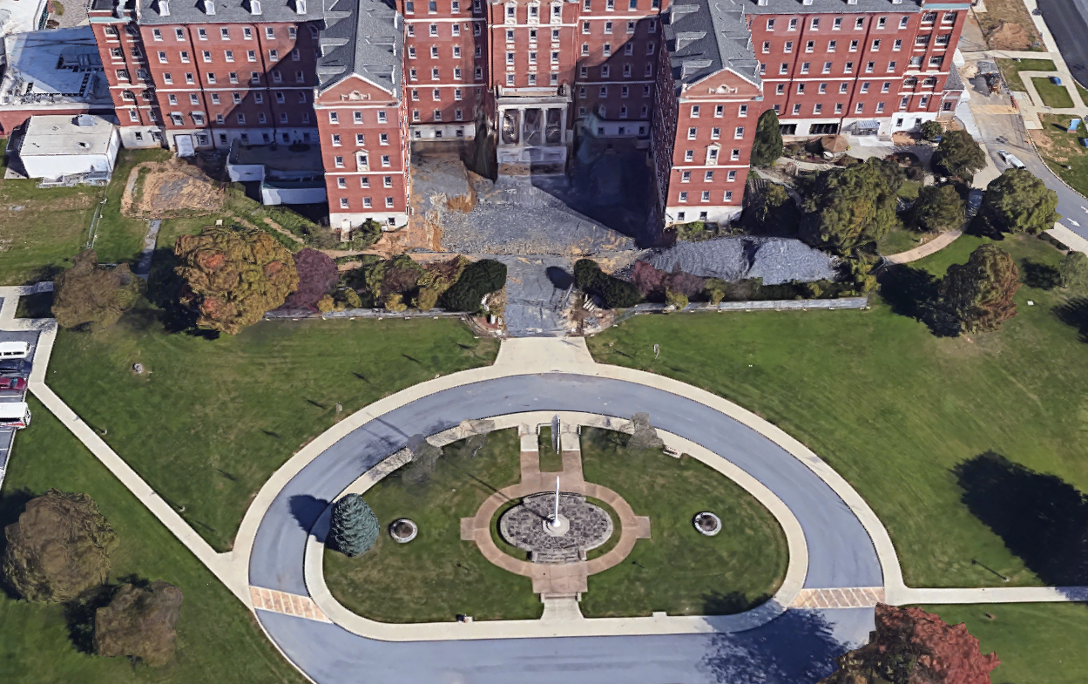

ATTACHMENT “B”
Design Development 35% Submission Requirements
Deliver the following (labeled with 35% submission) and include this attachment as a checklist with your submission:
- 1 Copy of a narrative report forwarding the design develop 35% submission addressing items listed in the design requirements and any additional A/E recommendations. The report should include identifying potential bid deduct alternatives, recommended construction phasing based upon discussions with the program manager, and any design calculations or analysis.

- 3 sets of all drawings updating all previous comments required by project and produced in AutoCAD 2007 – 2019 and in PDF form.

- 1 Copy of updated itemized cost estimate by spec section or trade (labor, material and equipment) and also by VA criteria, NRM, Minor, BSER and BSEA.

- 1 Copy of custom edited VA Master Specifications of sections to be used for this project and a master submittal list identifying all the submittals required to be submitted by the contractor for review.

- 1 set of all drawings and specifications, to send for 3rd party Life Safety Review.

- 1 copy of drawings in AutoCAD 2007 – 2019 and in PDF form and specifications in Microsoft Word 2007 or higher on (CD)
ATTACHMENT “C”
Design Development 100% Submission Requirements
Deliver the following (labeled with 100% submission) and include this attachment as a checklist with your submission:
- 1 Copy of a narrative report forwarding the design develop 100% submission addressing items listed in the design requirements and any additional A/E recommendations. The report should include identifying potential bid deduct alternatives, recommended construction phasing based upon discussions with the program manager and any design calculations or analysis.

- 2 sets of all drawings updating all previous comments required by project produced in AutoCAD 2007 – 2019 and in PDF form.

- 1 Copy of the proposed construction schedule.

- 1 Copy of final itemized cost estimate by spec section or trade (labor, material and equipment) and also by VA criteria, NRM, Minor, BSER and BSEA.

- 1 Copy of final edited VA Master Specifications of sections to be used for this project and a master submittal list identifying all the submittals required to be submitted by the contractor for review.

- 1 CD containing
  - All drawings in AutoCAD 2007 - 2019 and in PDF form.
  - All specifications in Microsoft Word 2007 or higher on (CD)
ATTACHMENT “D”
Contract Document Submission Requirements

Expectation: Submit complete contract documents for final review prior to Notice to Proceed for Construction. Continue to submit contract documents until all changes are incorporated by the DB A/E for final signature prior to Notice to Proceed for Construction. Upon approval duplicate copies as required.

Deliver the following (labeled with Contract Documents Submission) and include this attachment as a checklist with your submission:

- 1 copy of the Cover Sheet (AutoCAD) for final VA signatures.

- 2 sets of all drawings updating all previous comments required by project, produced in AutoCAD 2007 – 2019 and in PDF form – for final VA review. If approved final sets to be submitted with signed off cover sheet.
- 1 Copy of final project specification (bound) prepared in Microsoft Word 2007 or higher. Include a master submittal list in the specifications.
- CD containing
  - All drawings in AutoCAD 2007 – 2019 and in PDF form.
  - All specifications in Microsoft Word 2007 or higher.
  - Submittal Spreadsheet – identifying all the submittals required to be submitted by the contractor for review. The list shall be organized by division and specification.
Upon signature approval, provide three (3) sets of final Contract Documents (complete with VA signed Cover Sheet). Provide two (2), half (1/2) size sets of final drawings.

