**Replace Medical Vacuum Pump Building 1 – RFIs – Site Visit 2/20/2025**

1. What controls does the new Med Vac unit need to come with? How do those controls need to integrate to building automation system (i.e. what points list needs to be visible, communication protocol)? Which controls vendor can perform the integration at Lebanon VAMC?

**VA Response:** The new Med VAC pump assembly would require any controls which allow for proper integration and communication with the current BeaconMedaes master alarm panels.

Vendors with the appropriate ASSE certifications are permitted to install, test, and verify the facilities systems.

The current master alarm panels utilize a fiber-line for communications. This fiber line is owned and overseen by the VA Electrical shop.

1. Did/does the existing med vac unit function properly? Does the existing vacuum pump have sufficient capacity to support the facility, or will capacity need to be increased?

**VA Response:** Yes. The facility has used either Med Vac system to support the facility while the other Vacuum Pump system was out-of-service. The facility accomplished this by utilizing the cross-connection line/valve which is located on the ground floor of Building 104.

1. If relocating the unit, what does the piping run look like? Where are our connection points?

**VA Response:** There’s a 2” Med-Vac line that runs parallel with the building on the 5th floor. The connection point would be above the ceiling in the 5th Floor lobby. See attached LB-01-05MG.

1. If the existing vacuum pump is replaced in same location, will the existing vacuum pump to remain have capacity to support the Hospital or will temporary means be required?

**VA Response:** The vacuum pump in Bldg. 104 can support Bldg. 1.

To limit any potential issues with the operations of the facility, it is the VA’s request to limit the length of time that the facility will be relying on the Bldg. 104 vacuum pump assembly to support Bldg. 1.

1. If the pump is located on the 5th floor, is there Emergency Equipment or Emergency Critical switch gear available that has capacity to support the new vacuum pump?

**VA Response:** Panel 5CEQ 120V/208V (Fed From DP-EQ-1 BKR-1 RM55) has ATS backup. Contractor to verify the loading and capacity on 5CEQ to determine if the panel can handle the additional circuit required for the Med Vac System.

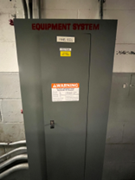 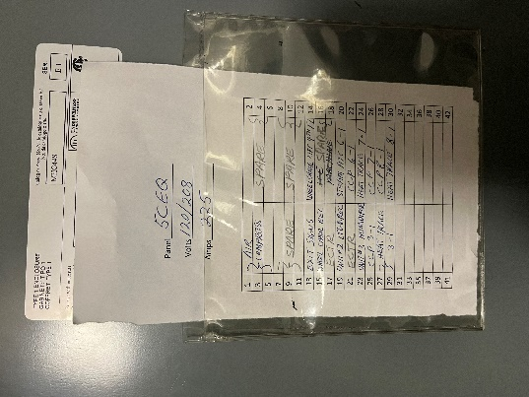

1. If the pump is located in alternate location, new alarm points in the master alarm panel will be required to permit testing of the new pump. What is the spare points available for the additional alarms on a temporary basis?

**VA Response:** The following are pictures of the master alarm panel located in the Emergency Department. Specific data points need to verified by the contractor.

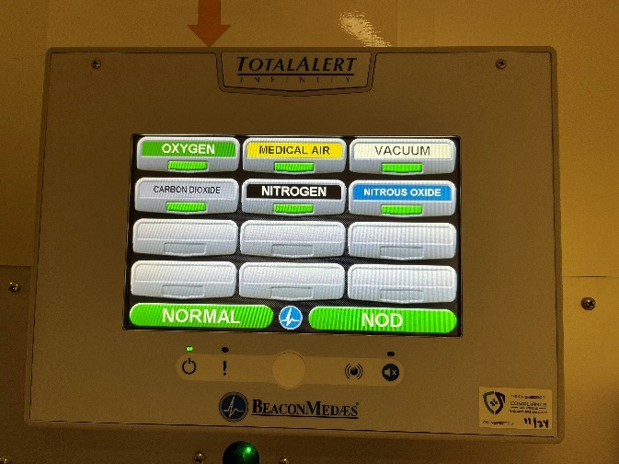 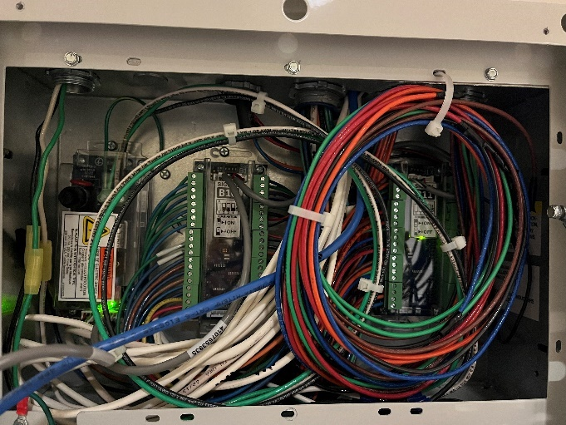

1. Are there known code/operational issues related to the med vacuum piping?

**VA Response:** No known issues

1. Are structural drawings available to analyze the equipment load on floors? We will assume no structural modifications are required but needs to be verified.

**VA Response:** Refer to the attached file *Original Drawings – Structural* for structural details. These drawings are not available in a digital format. The awarded contract would have access to review these drawings in-person for further review.

1. Does the medical gas master alarm panel have sufficient spaces to add new vacuum points if a new vacuum pump is installed while the existing to be demolished vacuum pump is in operation. How many spare points are available at the panels?

**VA Response:** Yes. The following are pictures of the master alarm panel located in the Emergency Department. Specific data points for use shall be verified by the contractor.

 

1. How determined is the VA to relocate the existing equipment from Building 1 attic to one of the other alternate locations?

**VA Response:** The VA would like to relocate the equipment as a convenience to the Government, without, causing any major renovations or additional work in areas outside of the identified locations.